**Create a React Application named “officespacerentalapp” which uses React JSX to create elements, attributes and renders DOM to display the page.**

**Create an element to display the heading of the page.**

**Attribute to display the image of the office space**

**Create an object of office to display the details like Name, Rent and Address.**

**Create a list of Object and loop through the office space item to display more data.**

**To apply Css, Display the color of the Rent in Red if it’s below 60000 and in Green if it’s above** **60000**.

Step1:Creating the officespacerentalapp and navigating into the folder





Step2: Creating an Element to Display the Heading

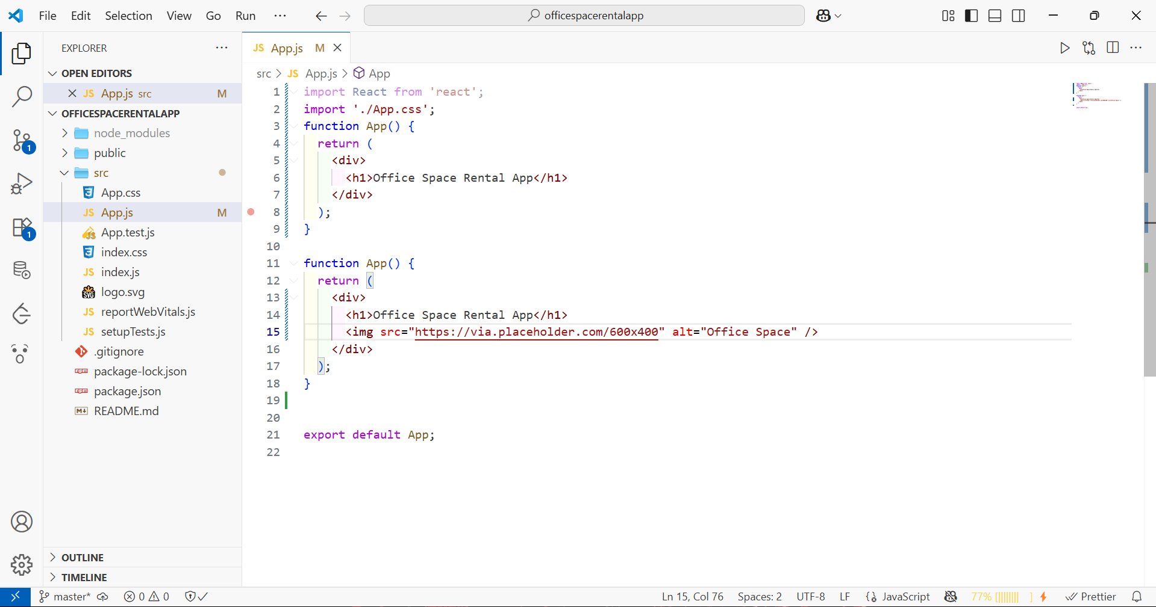

Step3: Creating an Object of Office Space Details

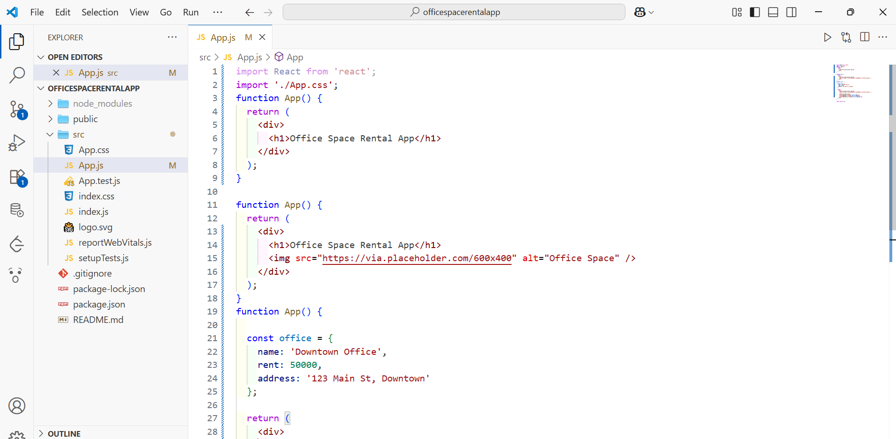

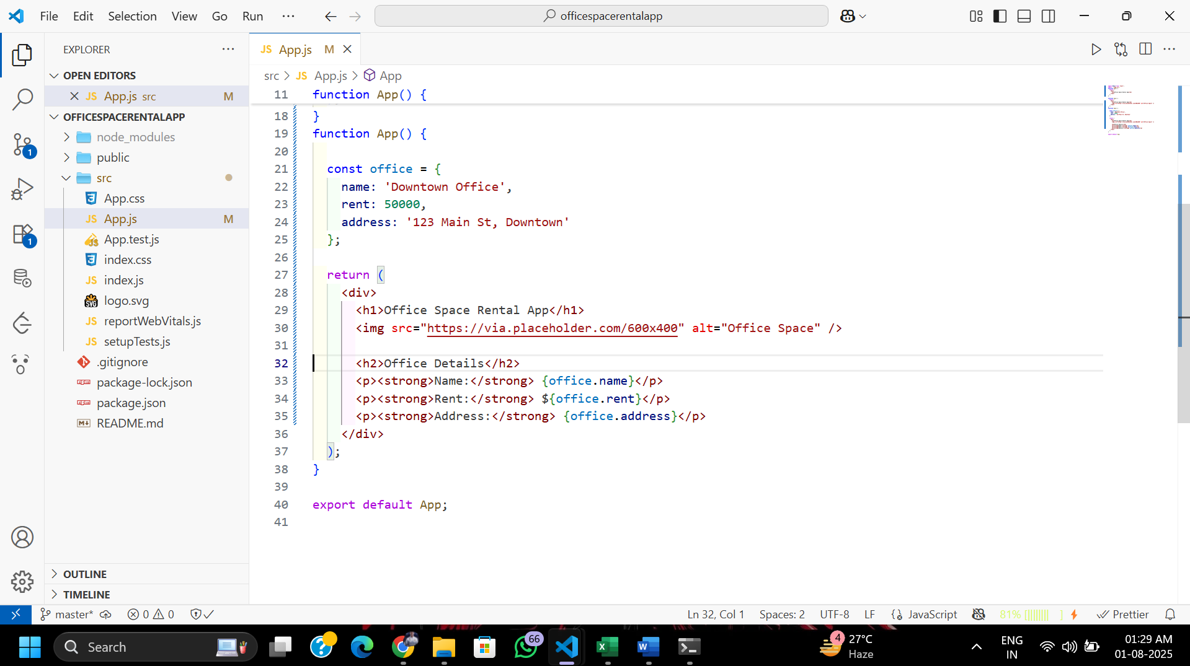

Step4:Creating a List of Office Space Objects and Loop Through Them

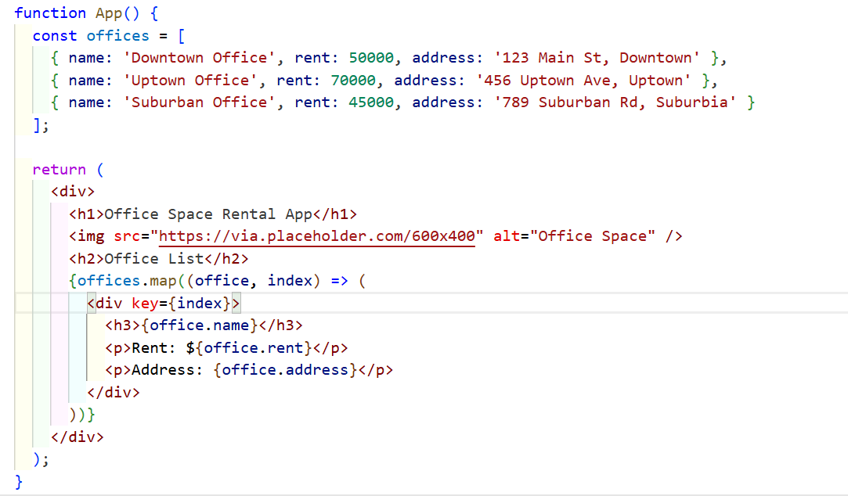

Step5: Applying Conditional Styling Based on Rent

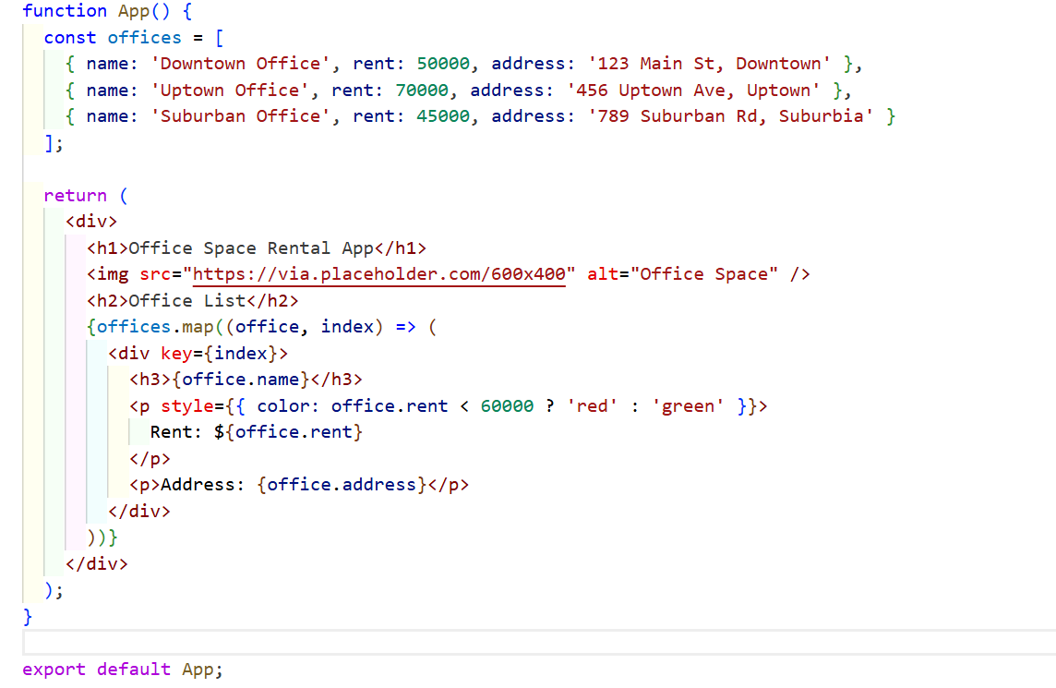

Step6:Running the application  